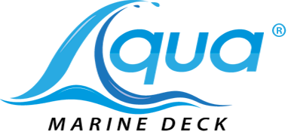
___________________________________________________________________________________
Application Instructions
TOOLS:
- Sharp razor knife
- Ammonia based window cleaner or Acetone (Preferred)
- Tape

VIDEOS OF INSTALLATION:
- Watch a video of installation at: www.aquamarinedeck.com

STORAGE:
- Should be stored flat in a cool, dry, indoor location until installed

LIMITATIONS:
- Do NOT install in temperatures below 60 degrees
- Do NOT attempt to remove and adjust placement once pad is down

PREPARATION:
- Clean surfaces followed by acetone on the area to be covered. Thoroughly clean all surface areas.
- Make sure all grease, adhesive, mold-release; wax and other substances are removed before installing the product. The area must be completely dry before applying Aqua Marine Deck product.
- All snaps must be removed and holes filled with JB Water Weld or caulk

INSTALLATION: *DO NOT PULL OR STRETCH THE PAD(S)*
- Before you peel back the adhesive backing, place the pads on the surface area to verify the fit and spacing in order to determine the exact location of the pad(s).
- Turn pad over so that the adhesive backing is face up. With a sharp razor knife carefully cut the paper adhesive backing down the center. Cut through the adhesive, but DO NOT cut into the pad.
- Peel back and fold the four corners of the paper backing.
- Turn the pad back over and reposition it.
- Secure one side of the pad to the surface area using tape. Taping prevents the pad from moving.
- Lift up the side that is not taped down and pull up the folded corners.
- From the center working towards the outer edges, slowly peel the rest of the paper backing while applying pressure to the pad to ensure there’s a firm bond to the surface area.
- Remove the masking tape from the other side of the pad and repeat step 7.
- Roll firmly, pressing down on all surface areas and especially the edges of the pad to ensure there’s a good adhesive. The 3M adhesive backing takes 14 PSI to activate. We recommend using the Kobalt Extension Handle Roller found at your local Lowe’s Home Improvement Store.
MAINTENANCE:
- NEVER use a pressure washer or bleach to clean the material.
- Clean decking with a soft carwash brush and Tide Liquid Laundry Soap
- Aqua Marine Deck sells EVA foam cleaner for purchase. Call for details.

